Questions:

* Are you satisfied that you have found the best solution? Explain.
  + Yes, I am definitely satisfied with the results. The sklearn library had better results, sure, but I am pleased with the results my implementation netted.

Data:

**1500 Iterations, Learn Rate = .01**

Initial

Weights:

[[0.70535518]

[0.52505136]

[0.24749174]

[0.53249171]

[0.90457313]

[0.25519864]

[0.10867305]]

Learning Rate: 0.01

Number of iterations: 1500

MSE: 0.5289686720330927

MSE v Testing: 0.4968034724904684

Final

Weights:

[[ 0.79471985]

[ 0.71753703]

[ 0.14489879]

[-0.34862268]

[ 0.16392958]

[-0.32779589]

[ 0.0975716 ]]

Learning Rate: 0.01

Number of iterations: 1500

MSE: 0.030628841866368044

MSE v Testing: 0.03040588857542107

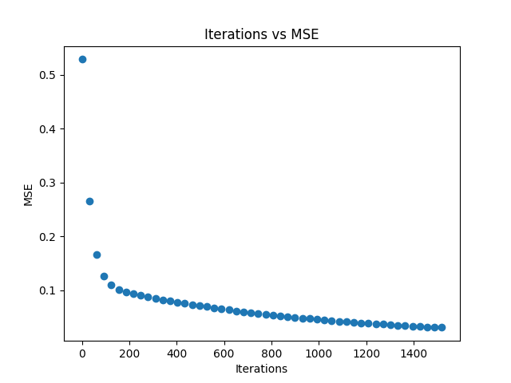

**1500 Iterations, Learn Rate = .1**

Initial

Weights:

[[0.39602717]

[0.6554227 ]

[0.12257876]

[0.62223919]

[0.11072597]

[0.86764447]

[0.02522587]]

Learning Rate: 0.1

Number of iterations: 1500

MSE: 0.24631697253360552

MSE v Testing: 0.22202791941500205

Final

Weights:

[[ 1.28780529]

[ 0.36061973]

[-0.03651368]

[-0.7855216 ]

[-0.8281184 ]

[-0.15082338]

[ 0.11291684]]

Learning Rate: 0.1

Number of iterations: 1500

MSE: 0.008080449010501341

MSE v Testing: 0.009245157055612938

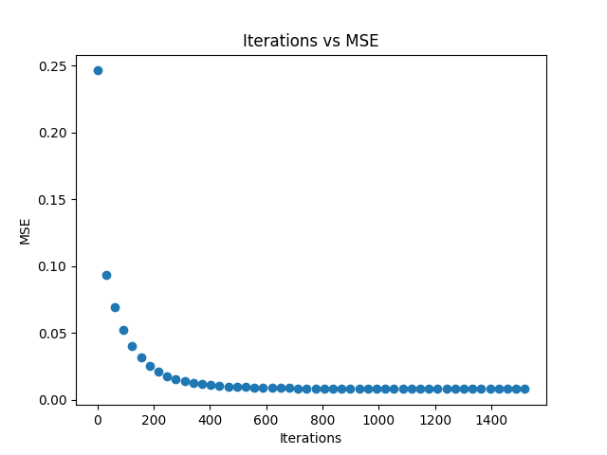

**150,000 Iterations, Learn Rate = .01**

Initial

Weights:

[[0.93966514]

[0.46485712]

[0.38195837]

[0.30450718]

[0.0098532 ]

[0.9260735 ]

[0.66949376]]

Learning Rate: 0.01

Number of iterations: 150000

MSE: 0.48627807850190635

MSE v Testing: 0.5329845354199131

Final

Weights:

[[ 1.27383751]

[ 0.3303976 ]

[ 0.20942001]

[-1.11902085]

[-0.42530243]

[-0.27972169]

[ 1.81026347]]

Learning Rate: 0.01

Number of iterations: 150000

MSE: 0.006983140084931775

MSE v Testing: 0.006028949832387835

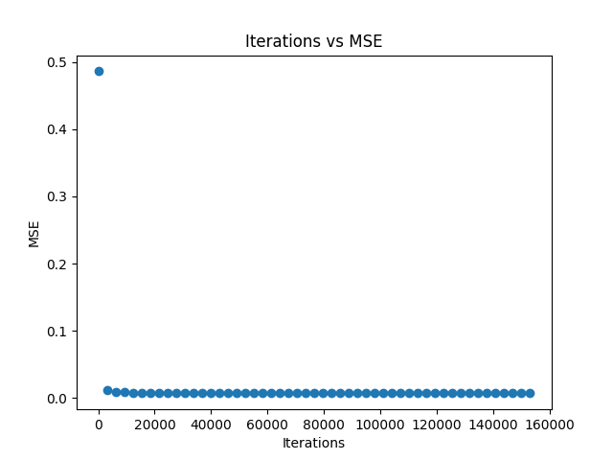

**150,000 Iterations, Learn Rate = .1**

Initial

Weights:

[[0.39819914]

[0.27741418]

[0.71673885]

[0.205572 ]

[0.06241018]

[0.28171542]

[0.44823835]]

Learning Rate: 0.1

Number of iterations: 150000

MSE: 0.10820323041012571

MSE v Testing: 0.10071398004176224

Final

Weights:

[[ 1.20631736]

[ 0.35159239]

[ 0.18023477]

[-1.16119499]

[-0.52540594]

[-0.42273738]

[ 8.83725182]]

Learning Rate: 0.1

Number of iterations: 150000

MSE: 0.002750171899306241

MSE v Testing: 0.0032429485280850625

